TARGET 6.3: By 2030, improve water quality by reducing pollution, eliminating dumping and minimizing release of hazardous chemicals and materials, halving the proportion of untreated wastewater and substantially increasing recycling and safe reuse globally

INDICATOR 6.3.2D: Proportion of bodies of water that comply to South African water quality objectives.
Indicator definition and method of computation (MoC)
DEFINITION: A measure of the quality of South Africa’s water resources expressed as the percentage of bodies of water that comply to a modified Level 1 set of water quality objectives from the Step_by_Step_Methodology_632_Revision_20180301. The specified variables are oxygen, salinity, nitrogen, phosphorus and pH. Oxygen measurements for South African river systems and most dams are very scarce, this indicator therefor excludes oxygen and adds a local indicator of acid mine drainage, i.e. the ionic ratio of sulphate to total ions.  In the case of rivers, waterbodies are tertiary catchments. For dams, each dam is a waterbody.  Good water quality status refers to bodies of water that comply to the South African uniform water quality objectives | MoC: Classify the quality of individual water bodies using a simple index based on the compliance of the monitoring data with the selected target values. For all monitoring sites within a water body, i.e. tertiary drainage region or dam, compare the monitoring values with the target values. Data from sites with a minimum of four samples or more per year are used. The index is the percentage of monitoring values that comply with the target values:  𝐶_{𝑤𝑞} = (𝑛_{𝑐}/𝑛_{𝑚}) × 100  𝐶_{𝑤𝑞} is the percentage compliance [%];  𝑛_{𝑐} is the number of monitoring values in compliance with the target values;  𝑛_{𝑚} is the total number of monitoring values.  A threshold value of 80% compliance is necessary for water bodies to have “good” quality. Thus, a body of water has a good quality status if at least 80% of all monitoring data from all monitoring stations within the water body are in compliance with the respective targets. Aggregate the results of the classification of single water bodies to the national level by calculating the proportion of classified water bodies classified as having a good quality status to the total number of classified water bodies. This is also a percentage:  𝑊𝐵𝐺𝑄 = (𝑛_{𝑔}𝑛_{𝑡}) × 100  𝑊𝐵𝐺𝑄 is the percentage of water bodies classified as having a good quality status;  𝑛_{𝑔} is the number of classified water bodies classified as having a good quality status;  𝑛_{𝑡} is the total number of monitored and classified water bodies
Baseline indicator value: 58%
Source: Water Management System (WMS), Department of Water and Sanitation

Comments:

Water quality data from 2014-2016 for South Africa’s rivers and dams using data from 329 monitoring sites ( covering 187 out of 278 drainage regions (tertiary drainage regions) or 67% of South Africa’s land surface) was used as the baseline for this indicator. Disaggregated this equates to 49% compliance to water quality objectives for Rivers and 72% compliance for dams. Areas with non-perennial rivers (and thus where there is no flow) are typically not monitored (are unassessed).

Oxygen
The South African water quality monitoring network does not include oxygen measurements because of the logistics. Field measurements would require procurement, maintenance and five-yearly replacement of sufficient oxygen meters for everyone collecting samples. Regular training in the calibration and use of the instruments would also be necessary. An alternative, the Winkler oxygen titration, would require collection and fixing of samples in the field, and their delivery to the laboratory in airtight glass containers within 48 hours of sampling. Conversion of this to a flow-injection process would incur additional development and accreditation costs.
Adopting either method would require the establishment of a new SDG 6.3.2 baseline with all variables for a period of a year or more.

SO4/Total ion ratio
A proposed alternative variable that measures a different characteristic of water, namely neutralised acid mine drainage, is the ratio of sulphate ion to the total ions in a sample. During normal inorganic laboratory operation, this ratio is a free by-product of cation: anion balance verification. The disadvantages of the indicator are that is only of use in certain types of catchments affected by mining.

Target values
Target values represent uniform limits (or resource water quality objectives) based on the South African 1996 Water Quality Guidelines and the 2008 South African water quality guideline for freshwater ecosystems. The values are “tolerable” in the sense of the Planning level review of Water Quality in South Africa (DWA, 2011).

EC-Phys-Water <= 85 mS/m (South African ecosystems)
NO3+NO2-N-Diss-Water <= 2.5mg/L (generic nutrient)
PO4-P-Diss-Water <= 0.025 mg/L (generic nutrient – dams)
PO4-P-Diss-Water <= 0.125 mg/L (generic nutrient – rivers)
pH-Diss-Water 6.5 - 8.4 (agriculture)
SO4Ion/MajAnions-Wat <= 0.4 (suggested acid mine drainage indicator)
O-Diss-Water >= 6.0 arbitrary ecosystems target range for SDG 6.3.2 level 1 (not used for RWQO-based assessment)

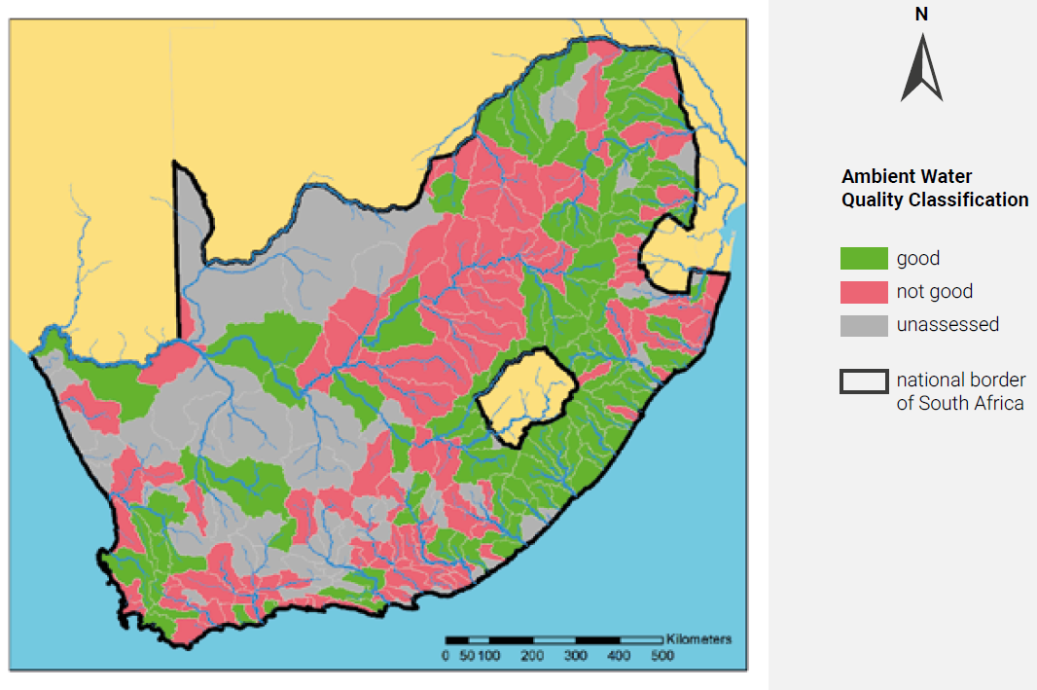
Figure 1. Tertiary catchment assessments for 2014-2016. From: UNEP 2018 Progress on Ambient Water Quality - Piloting the monitoring methodology and initial findings for SDG 6 indicator 6.3.2, page 26

